**6 - Forms in ServiceNow**

A **form** displays fields from one record, and the specific information on a form depends on the record type. Users can only view and edit fields they have access to. Forms can also have sections (like Notes, Analysis Information, Resolution Information, and Other Information) and Related Lists. Related Lists show records from tables related to the current record and only appear once the record is saved.

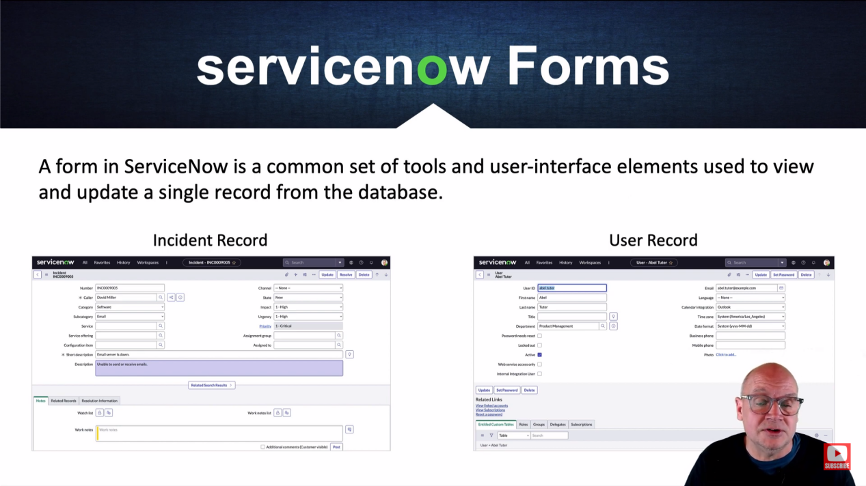

**Form Layout** :-

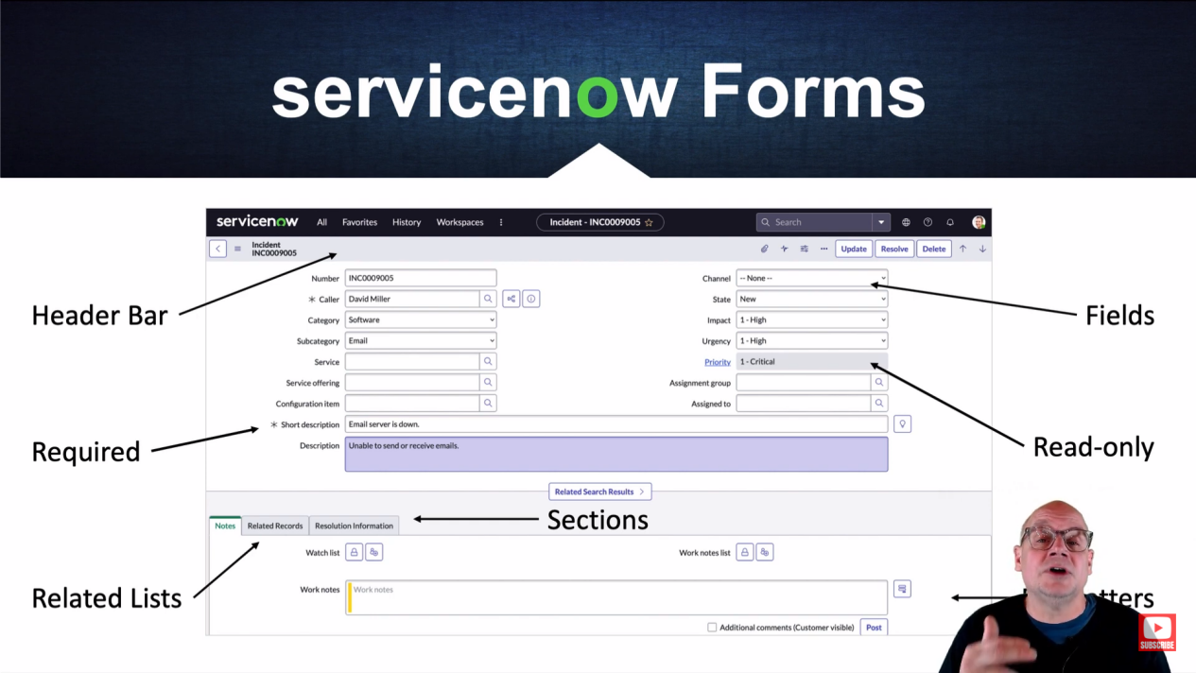

Back - Takes you back to the original list of records.

Form Context Menu (Additional actions) - Provides options specific to the form. You can save the form here without leaving the page. Right-clicking on the form header also lets you save the record.

Record Title - Shows the name of the record. If it's not the Default view, the view name also appears.

Manage Attachments - Add or remove files using the paperclip icon.

Activity Stream - Shows the list of activities or history on the form, like comments and work notes.

Personalize Form - Allows you to choose which fields to display. Unchecked boxes indicate hidden fields.

More options menu - The three dots (...) give more options based on the form, like emailing users, managing templates, and adding tags.

Submit/Update - Submit a new record or update an existing one.

Resolve - Specific to Incident forms, allows resolving the incident with a button click.

Previous/Next Record - Navigate through records with the upward and downward arrows, available if you selected a record from a list.

**Related Lists** - Show records from related tables, presented as tabs at the bottom. You can edit or create new records from these lists and personalize columns, filter, or refresh the list.

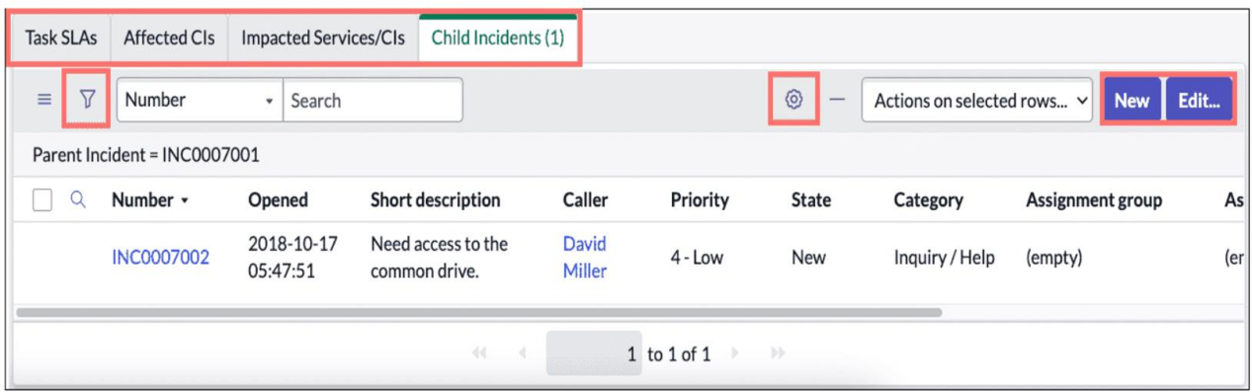

**Form Personalization -** Click the gear icon to choose which fields to display. Fields can be hidden by unchecking boxes or using the Hide icon. You can also reset the form to its default settings.

**Formatters -** A formatter displays information that isn't a field, like Activity Stream or Work Notes/Customer Comments.

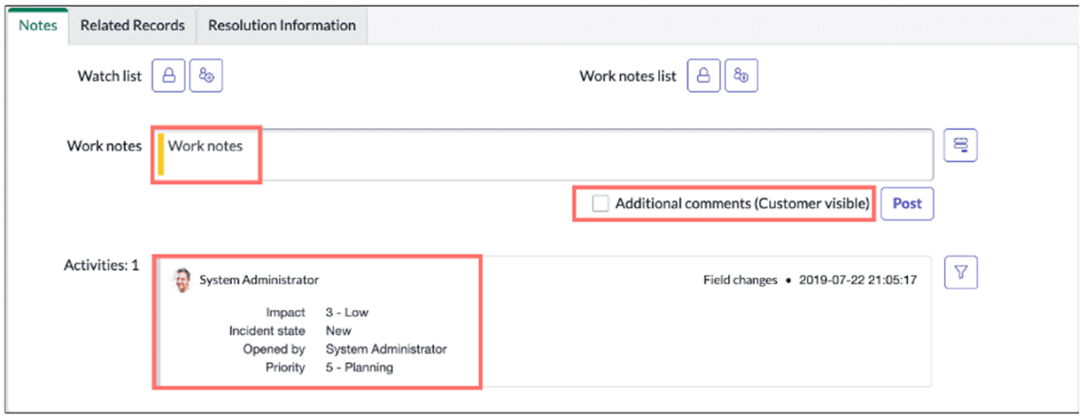

**Form Templates -** Templates automatically populate fields, making it easier to create new records. You can personalize templates by selecting one, adding the needed fields, and saving your changes.

